**Chapter 1: Introduction**

**1.1 Micro Blogging**

Micro blogging today has become a very popular communication tool among Internet users. Millions of users share opinions on different aspects of life every day. Therefore micro blogging web-sites are rich sources of data for opinion mining and sentiment analysis. Twitter is a social networking and a micro blogging service, enabling registered users to read and post short messages, so-called tweets. It is a massive social networking site tuned towards fast communication. More than 140 million active users publish over 400 million 140- character “Tweets” every day2. Twitter’s speed and ease of publication have made it an important communication medium for people from all walks of life. Twitter has played a prominent role in socio-political events, such as the Arab Spring3 and the Occupy Wall Street movement4. Twitter has also been used to post damage reports and disaster preparedness information during large natural disasters, such as the Hurricane Sandy. As of end of 2017, the micro blogging service averaged at 328 million monthly active users generating 8 TB of data every day.

Text mining or text data mining, roughly equivalent to text analytics, is the process of deriving high-quality information from qualitative or unstructured data. Qualitative data is descriptive data that cannot be measured in numbers and often includes qualities of appearance like color, texture, and textual description. Microblogging today has become a very popular communication tool among Internet users. Millions of messages are appearing daily in popular web-sites that provide services for microblogging such as Twitter, Tumblr, Facebook etc. Authors of those messages write about their life, share opinions on variety of topics and discuss current issues. Because of a free format of messages and an easy accessibility of micro blogging platforms, Internet users tend to shift from traditional communication tools (such as traditional blogs or mailing lists) to micro blogging services. As more and more users post about products and services they use, or express their political and religious views, microblogging web-sites become valuable sources of people’s opinions and sentiments. Such data can be efficiently used for marketing or social studies. Twitter contains a very large number of very short messages created by the users of this microblogging platform. The contents of the messages vary from personal thoughts to public statements in text mining. People unfamiliar with textmining may have a problem framing a sentiment analysis problem: Should they count up “negative” and “positive” words in a dictionary? How can we correlate this with the documents? What about sarcasm?

Analyzing this vast quantity of unstructured data presents challenges for software and hardware.

**1.2 How does twitter work?**

Besides the basic function of posting a Twitter message (called “tweet”), and the possibility to follow and be followed by other users, Twitter provides several other specific features. Three of these are “replies”, “mentions” and “retweets”. Replying to a user by starting a tweet with an @ sign followed by the user name (*@user*) makes it possible to address a user directly via the public Twitter feed. To mention another user, works in a similar way; it also includes *@user* but not at the beginning of a tweet. The difference is that a reply is directed to the other user and therefore seen by him or her, while a mention is not directed at the user. You could also say a reply is a message *for* someone while a mention is a message *about* someone. By using the retweet function a user spreads the original message from another user by resending it. While mentioning is a way of referring to another user without necessarily sharing the same opinion, a retweet can be seen as an informal recommendation of a message that another user finds important, interesting or at least entertaining. Therefore the retweet function is a key mechanism for information diffusion and raising content visibility on Twitter.

Another key function of Twitter is the use of “hashtags”. Putting a “#” (hash) sign in front of a certain word is a simple way of adding context to a message. This can be a name (e.g. *#obama*), an event (e.g. *#election2016*), a movement (*#refugeeswelcome*), a conference (e.g. *#futuresconference2015*) or anything else. By adding a hashtag to a Tweet, the referred word receives the informal function of a topic. Thus, hashtags are helpful when sharing news, knowledge or general contributions to a certain topic, and to spread information across networks of interest. Conversely, hashtags make it easy to search and collate information, discussions or central actors regarding a specific theme. Also, hashtags can be especially useful when Twitter is used as a communication platform, for example during a conference to share ideas, impressions, comments and additional materials on a “#channel“.

While each tweet can be retweeted, be addressed to other users by replies, or relate to specific context by a hashtag, information spreading on Twitter can also work in other ways: Tweets can additionally contain photos, videos with a maximum length of six seconds or additional web links. The latter is particularly interesting for Foresight practitioners who want to use Twitter as a data source, since they might refer for example to news articles, studies, or reports relevant to the theme under investigation.

**1.3 Who uses twitter and why?**

With the growing popularity of Twitter, not only has the “daily chatter”, as Java et al. describe it, increased but also the service’s potential as a fast information distribution platform, as a tool for coordination in disaster control/response, or as an instrument for political campaigns. By the time Twitter reacted to the predominant way people used the platform and changed its initial question in 2010 from “What are you doing?” to “What’s happening?” focusing on ongoing news and events. Other changes Twitter made in reaction to the user behavior are even more remarkable: Both retweets and hashtags were first initiated by users without having a formal function to use it; this was a matter of self-initiative in order to spread information or add context to a message. Twitter later implemented these features formally, which are now two of the services’ most important functions.

A study from Smith and Brenner gives some hints on what a “typical Twitter user” in the United States might look like. Although the results might be different considering a European sample it seems plausible to assume at least a similar demographic tendency. According to the results of the study most of the Twitter users are younger, with a higher education, more affluent showing a bigger political interest than the average. It is therefore important to note that a Twitter data analysis cannot be seen as a representative sample of a population. Such data can only provide insights in the online communication of the part of the population using this specific online service. This does not necessarily make such data less important or less interesting for social scientists or Foresight practitioners. In fact, focusing on a group that shows a relatively high level of involvement and interest in societal issues might be fruitful depending on the specific topic of research.

**Chapter 2: Data Collection**

**2.1 Why Twitter**

Amongst all the social media websites Twitter which receives tweets in millions every day, is the largest social media. For industrial or business purpose this huge amount of raw data can be used by organizing according to our requirement and processing. Starting with an authentication on Twitter’s streaming API so as to obtain the data or the Tweets.

Users on Twitter generate over 400 million Tweets everyday1. Some of these Tweets are available to researchers and practitioners through public APIs at no cost.

**2.2 Types of API**

APIs to access Twitter data can be classified into two types based on their design and access method:

**2.2.1 REST APIs**

They are based on the REST architecture2 now popularly used for designing web APIs. These APIs use the pull strategy for data retrieval. To collect information a user must explicitly request it.

**2.2.2 Streaming APIs**

They provides a continuous stream of public information from Twitter. These APIs use the push strategy for data retrieval. Once a request for information is made, the Streaming APIs provide a continuous stream of updates with no further input from the user.

They have different capabilities and limitations with respect to what and how much information can be retrieved. The Streaming API has three types of endpoints:

* Public streams: These are streams containing the public tweets on Twitter.
* User streams: These are single-user streams, with to all the Tweets of a user.
* Site streams: These are multi-user streams and intended for applications which access Tweets from multiple users.

Twitter APIs can be accessed only via authenticated requests. Twitter uses Open Authentication and each request must be signed with valid Twitter user credentials. Access to Twitter APIs is also limited to a specific number of requests within a time window called the rate limit. These limits are applied both at individual user level as well as at the application level. A rate limit window is used to renew the quota of permitted API calls periodically. The size of this window is currently 15 minutes.

**2.3 Outh Authentication**

Open Authentication (OAuth) is an open standard for authentication, adopted by Twitter to provide access to protected information. Passwords are highly vulnerable to theft and OAuth provides a safer alternative to traditional authentication approaches using a three-way handshake. It also improves the confidence of the user in the application as the user’s password for his Twitter account is never shared with third-party applications. The authentication of API requests on Twitter is carried out using OAuth. Twitter APIs can only be accessed by applications. Below we detail the steps for making an API call from a Twitter application using OAuth:

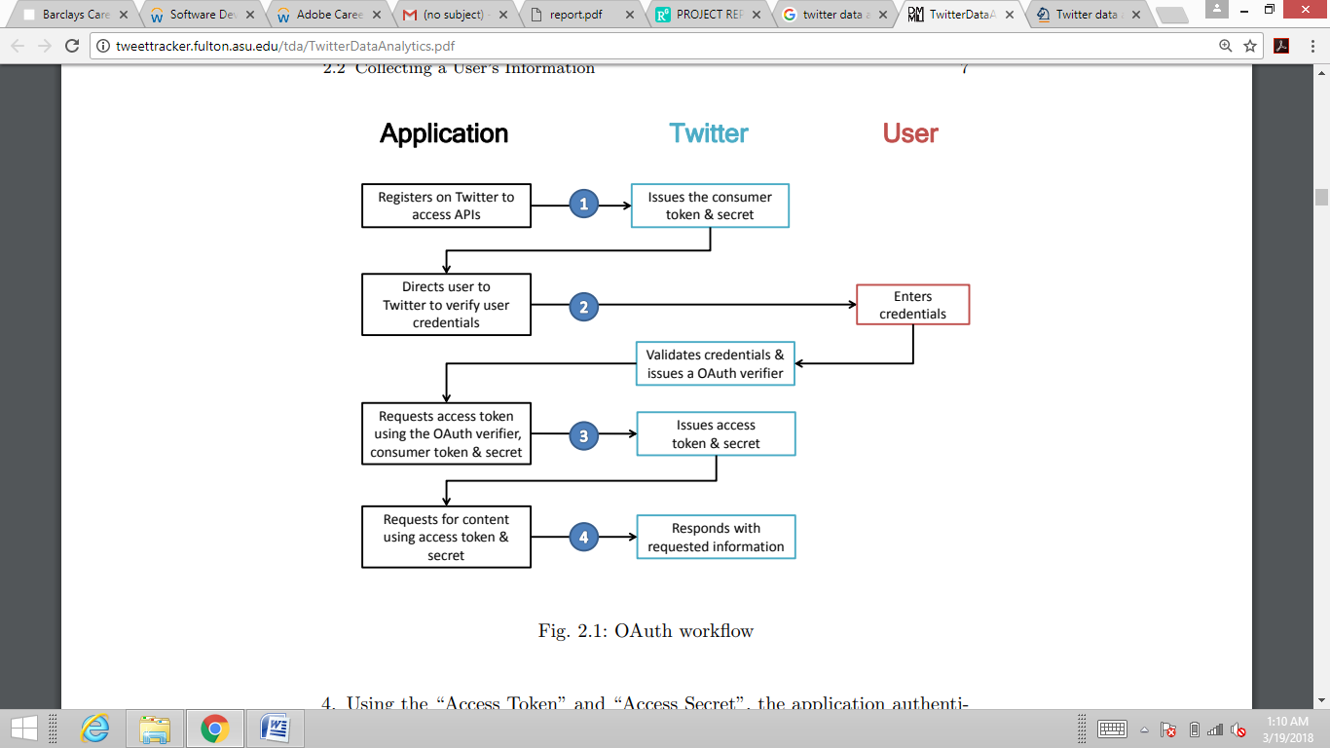

**Figure 2.1 : Outh WorkFlow**

1. Applications are also known as consumers and all applications are required to register themselves with Twitter4. Through this process the application is issued a consumer key and secret which the application must use to authenticate itself to Twitter.

2. The application uses the consumer key and secret to create a unique Twitter link to which a user is directed for authentication. The user authorizes the application by authenticating himself to Twitter. Twitter verifies the user’s identity and issues a OAuth verifier also called a PIN.

3. The user provides this PIN to the application. The application uses the PIN to request an “Access Token” and “Access Secret” unique to the user

4. Using the “Access Token” and “Access Secret”, the application authenticates the user on Twitter and issues API calls on behalf of the user.

**Chapter 3: Data Processing**

**3.1 Pre-Processing Textual Data**

Pre-processing the data is the process of cleaning and preparing the text for the classification process. The necessity for this step lies in the fact that online texts contains usually noise and uninformative parts such as HTML tags, scripts and advertisements. In addition, on words level, many words in the text do not have an impact on the general orientation of it. Since each word in the text is treated as one dimension, keeping irrelevant words increases the dimensionality of the problem and hence makes the classification more difficult. The difficulties do not only manifest themselves in the robustness of the analysis, but also in the computational complexity of the classification process. The entire pre-processing procedure involves several steps: online text cleaning, white space removal, abbreviation expansion, stemming, stop words removal, negation handling and feature selection.

All of the steps but the last one are called transformations, while the last step is called filtering.

**3.2 Transformations**

3.2.1. HTML Cleanup

Web-pages contain in addition to the main texts advertisements, and other irrelevant information such as HTML tags (for example <p> , <br> ). These are organised in different object elements, i.e. so called <div> tags. To avoid efficiency problems that arise from that irrelevant information, the text should be cleaned from them to retain only the information of interest. There are many ways to extract the relevant news texts from the HTML source code. For example, one can use “HTML Cleanup” which was used in, or the document object model(DOM), or the Apache library HTMLUnit which can parse the HTML specific features from texts, and arrange them in an object-based tree structure to be distinguished and separated from each other. This structure allows then to extract the core text of interest.

3.2.2. Expanding Abbreviation

Next to computer language specific pollutions of the text that have been discussed in the previous paragraph, abbreviations can create noise in the course of the analysis. This problem is solved by abbreviation expansion. For instance, they’re is substituted by they are, hasn’t is substituted by has not, and so on. This helps on one hand to get the correct frequency of the words and then the correct dimension of the text. On the other hand, expanding the negation part as in don’t like → do not like helps to detect and tag the negation in the sentences and facilitate their detection. Negation cases are of great importance in sentiment analysis as they reverse the sentence sentiment. More about negation handling will be explained later.

3.2.3. White Space And Stopwords Removal

Some parts of the text might contain two white spaces especially after the removal of the HTML tags. White space removal is the process of removing one of those spaces for each occurrence of two spaces. Stopwords are words which have no discriminant value in the text, or do not add any information to the general orientation of the text in terms of sentiment classification. Moreover, their existence causes less accurate results and longer processing time due to the increase in the text’s dimensionality without additional information. Makrehchi and Kamel divide the stopwords into two groups, general stopwords and domain specific stopwords. General stopwords are either standard and the are available in public domain or non-standard and they are generated from the systems of text categorisation or information retrieval. Domain specific stopwords are words that are used in a certain domain. The stopword in one domain can be a keyword in another one. For example, the word learning is a stopword in any education domain while it is a keyword in the computer science domain.

Although domain specific words are essential in text categorisation or topic categorisation, they are of little importance in sentiment analysis as they do not have an impact on the text orientation. Therefore, they are usually removed among general stopwords for dimensionality reduction. There exist different methods of stopwords removal. One of them uses a list of stopwords, called a stoplist. The stoplist contains words that are considered to be non-informative generally. Such stoplists are publicly available. In the literature, the Rijsbergen stoplist is one of the widely used stoplists in natural language processing. Still, stoplists are continuously outdated after their publication, and that is because of the change in words usage over time due to social factors and changes in technology. Therefore, they should be always scrutinised and updated. Other ways of constructing stoplists is based on the frequencies of the words in a text. Words with high frequencies are treated as stopwords. As for domain specific stopwords, stoplists are usually constructed from a dictionary or a corpus for the domain in question.

3.2.4 Handling Negation : It is of high importance in sentiment analysis due to the fact that one negation word would change the polarity of the sentence from one side to the other. An example is the two very similar sentences that have opposite sentiments, I like this book, I don’t like this book. There exit different types of negations. The sentence may contain a direct negation such that the negation word and the negated words are neighbors, take for instance “not nice”. The sentence may also contain a long distance negation where the negation and negated words are separated such as” not very interesting, does not have good music”. The negation could be for the subject (e.g., “no one liked it”), or the verb (e.g., “did not succeed”), or adjective/adverbs phrases (e.g., “not really interesting”). In addition to those different types, in some cases, negation words do not reverse the sentiment of the sentence. For example, in the sentence “Not only the actors choice attracted me but also the music”, the negation does not reverse the sentiment, it enhances it. Thus, negation handling is important in sentiment analysis. Negation can be controlled in different ways. Some studies use a linguistic approach to handle the negation by composing a negation phrase and treating it as a unigram. The negation phrase could be the negation word with corresponding negated word, for instance, “not good” will be “good NOT”. It could also be a phrase that contains the negation word and the all the words that occur after the negation until the first punctuation appears. Others distinguish between the different types of negation that are mentioned previously and tag the negation on a phrase level by combining different structures of negation phrases. Narayanan, Liu, and Choudhary use two strategies: the first one is to tag the negation word as a feature, and the second is to reverse the sentiment after finding the sentiment of the sentence. They report that the first approach is more accurate in terms of correct classification

Then regular expressions were used to remove certain undesirable texts such as emorticons , @, punctuations, retweets [rt] ,urls etc from the tweets we have retrieved.

1. Remove Retweets
2. Remove all urls
3. Remove all White Spaces
4. Remove Punctuation
5. Remove Stop words

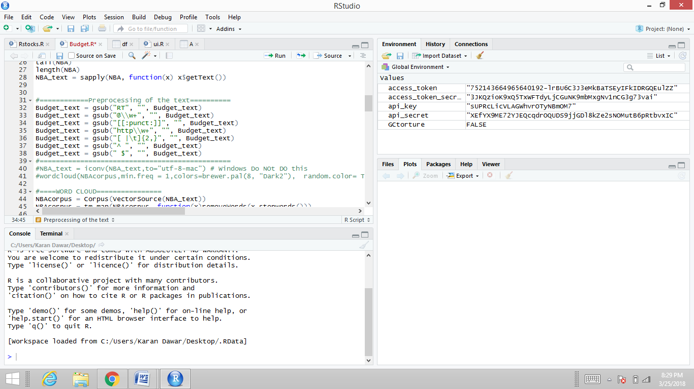

**Chapter 4: Analysis**

**4.1 Word Cloud**

Word clouds or tag clouds are graphical representations of word frequency that give greater prominence to words that appear more frequently in a source text. The larger the word in the visual the more common the word was in the document(s). This type of visualization can assist evaluators with exploratory textual analysis by identifying words that frequently appear in a set of interviews, documents, or other text. It can also be used for communicating the most salient points or themes in the reporting stage.

A variety of word and tag cloud generators are freely available on the internet and the process for creating them is straightforward. Evaluators can simply import text (for example, a set of interviews) into a text box and the tool creates a graphical representation of the words. Most word cloud generators have features that allow users to change colors, font, and exclude common or similar words.

In the last few years, word clouds have become a standard tool for abstracting, visualizing, and comparing text documents. For example, Word clouds were used in 2008 to contrast the speeches of then US presidential candidates Obama and McCain. A word cloud of a given document consists of the most important (or most frequent) words in that document. Each word is printed in a given font and scaled by a factor roughly proportional to its importance (the same is done with the names of towns and cities on geographic maps, for example). The printed words are arranged without overlap and tightly packed into some shape (usually a rectangle).

**4.2 Hierarchical Clustering**

Hierarchical clustering is an alternative approach to k-means clustering for identifying groups in the dataset. It does not require us to pre-specify the number of clusters to be generated as is required by the k-means approach. Furthermore, hierarchical clustering has an added advantage over K-means clustering in that it results in an attractive tree-based representation of the observations, called a dendrogram.

Hierarchical clustering can be divided into two main types: *agglomerative* and *divisive*.

1. **Agglomerative clustering:** It’s also known asAGNES (Agglomerative Nesting). Itworks in a bottom-up manner. That is, each object is initially considered as a single-element cluster (leaf). At each step of the algorithm, the two clusters that are the most similar are combined into a new bigger cluster (nodes). This procedure is iterated until all points are member of just one single big cluster (root) (see figure below). The result is a tree which can be plotted as a dendrogram.
2. **Divisive hierarchical clustering:** It’s also known as DIANA (Divise Analysis) and itworks in a top-down manner. The algorithm is an inverse order of AGNES. It begins with the root, in which all objects are included in a single cluster. At each step of iteration, the most heterogeneous cluster is divided into two. The process is iterated until all objects are in their own cluster (see figure below).

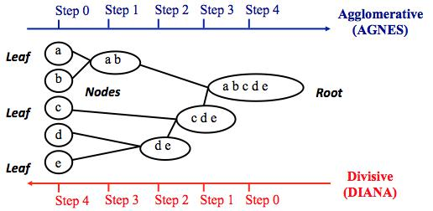

**Figure 4.1 Agnes versus Diana**

In R, the Euclidean distance is used by default to measure the dissimilarity between each pair of observations. As we already know, it’s easy to [compute the dissimilarity measure](https://afit-r.github.io/kmeans_clustering#distance) between two pairs of observations with the get_dist function.

*How do we measure the dissimilarity between two clusters of observations?* A number ofdifferent cluster agglomeration methods (i.e, linkage methods) have been developed to answer to this question. The most common types methods are:

1. **Maximum or complete linkage clustering:** It computes all pairwise dissimilaritiesbetween the elements in cluster 1 and the elements in cluster 2, and considers the largest value (i.e., maximum value) of these dissimilarities as the distance between the two clusters. It tends to produce more compact clusters.
2. **Minimum or single linkage clustering:** It computes all pairwise dissimilaritiesbetween the elements in cluster 1 and the elements in cluster 2, and considers the smallest of these dissimilarities as a linkage criterion. It tends to produce long, “loose” clusters.
3. **Mean or average linkage clustering:** It computes all pairwise dissimilarities betweenthe elements in cluster 1 and the elements in cluster 2, and considers the average of these dissimilarities as the distance between the two clusters.
4. **Centroid linkage clustering:** It computes the dissimilarity between the centroid forcluster 1 (a mean vector of length p variables) and the centroid for cluster 2.
5. **Ward’s minimum variance method:** It minimizes the total within-cluster variance.At each step the pair of clusters with minimum between-cluster distance are merged.

We can see the differences these approaches in the following dendrograms:

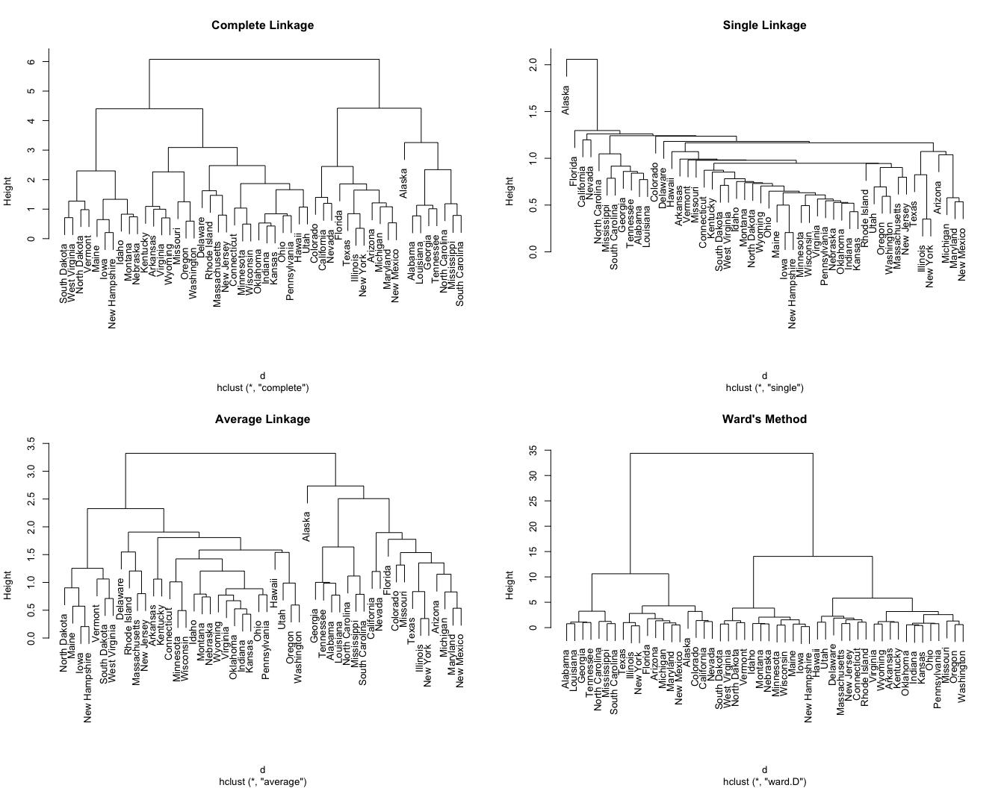

**Figure 4.2 Different approaches of Dendrogram**

**4.3 Topic Modeling**

In text mining, we often have collections of documents, such as blog posts or news articles, that we’d like to divide into natural groups so that we can understand them separately. Topic modeling is a method for unsupervised classification of such documents, similar to clustering on numeric data, which finds natural groups of items even when we’re not sure what we’re looking for.

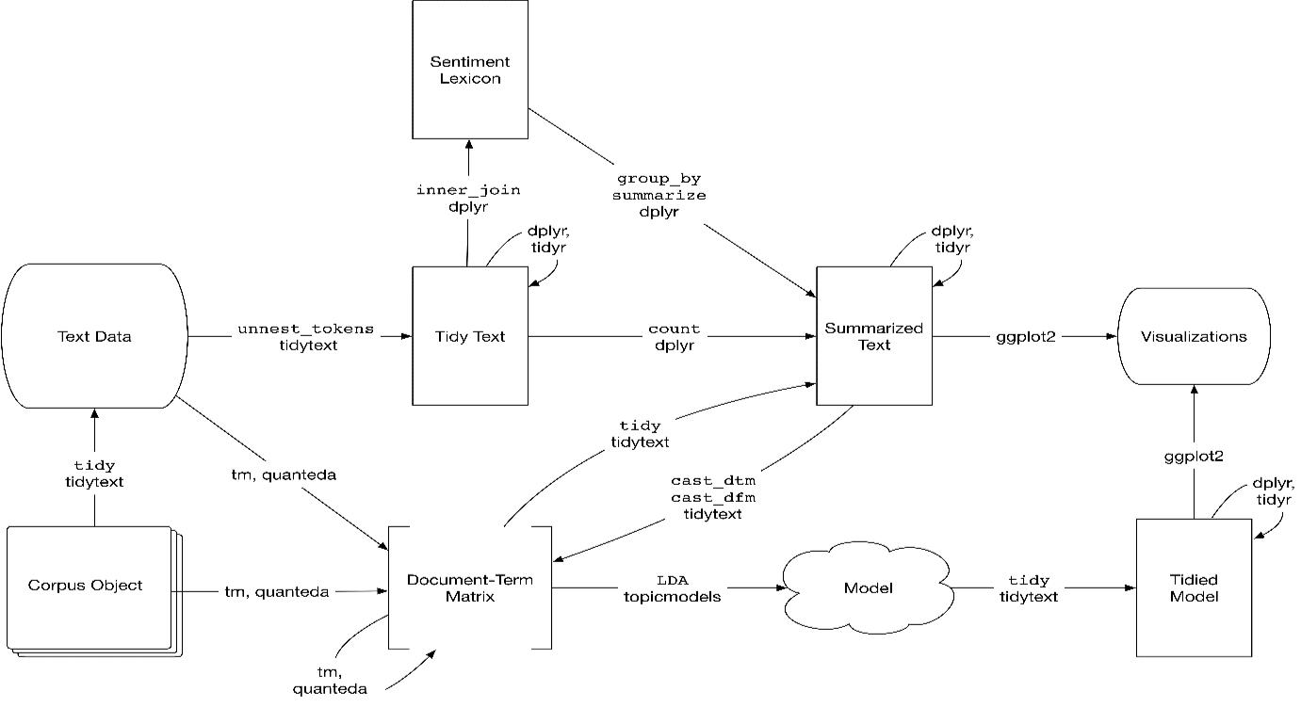

**Figure 4.3 A flowchart of a text analysis that incorporates topic modeling. The topicmodels package takes a Document-Term Matrix as input and produces a model that can be tided by tidytext, such that it can be manipulated and visualized with dplyr and ggplot2.**

Latent Dirichlet allocation (LDA) is a particularly popular method for fitting a topic model. It treats each document as a mixture of topics, and each topic as a mixture of words. This allows documents to “overlap” each other in terms of content, rather than being separated into discrete groups, in a way that mirrors typical use of natural language.

**4.3.1 Latent Dirichlet allocation**

Latent Dirichlet allocation is one of the most common algorithms for topic modeling. Without diving into the math behind the model, we can understand it as being guided by two principles.

1. **Every document is a mixture of topics.** We imagine that each document may containwords from several topics in particular proportions. For example, in a two-topic model we could say “Document 1 is 90% topic A and 10% topic B, while Document 2 is 30% topic A and 70% topic B.”
2. **Every topic is a mixture of words.** For example, we could imagine a two-topic model ofAutomotive parts, with one topic for “bikes” and one for “cars.” The most common words in the bikes topic might be “Clutch”, “Speed”, and “Average”, while the cars topic may be made up of words such as “Fees”, “Distance”, and “Model year”. Importantly, words can be shared between topics; a word like “vehicle” might appear in both equally.

LDA is a mathematical method for estimating both of these at the same time: finding the mixture of words that is associated with each topic, while also determining the mixture of topics that describes each document. There are a number of existing implementations of this algorithm, and we’ll explore one of them in depth.

**4.4 Sentiment Analysis**

In researching how a machine learning system can successfully identify emotions in a document, we must first grasp the essence of what an emotion is, and how it can be defined. This chapter will outline the relevant literature, and cast light on the range of definitions that have been put forward over the years. This will show that while emotions come as second-nature to many of us, requiring little thought in their production, the models that have been proposed vary greatly in two main ways. The first is the types of emotion which the model consists of. Despite emotions being part of our everyday lives, there is little agreement on what the types of emotion that we express are. The second is the dimensionality of emotions. Some believe that emotions can differ in intensity, and therefore can be seen as dimensional notions which can be assigned scalable values. With these models in mind, this chapter will conclude with a summary of the emotional models presented, and highlight which ones should be investigated further in this research.

**4.4.1. Differences in Definition**

The definition of emotion is one which is unclear, despite being a phenomenon which occurs frequently in our lives. The problem with defining emotion is that mentally it is experienced by so many, yet physically and verbally the forms of expression vary. This can make recognition challenging if common forms of expression are to be relied on. If however we are to successfully recognise emotions, particularly in text, a universal model must exist. Unfortunately this is something that is difficult to define. Researchers have put forward definitions in an attempt to pinpoint what emotion is, and to describe the sequence of events that could combine in the inception of one. By doing this they have also attempted to describe just what types of emotion there are, and as we will note, consensus on this issue is lacking. Kleinginna & Kleinginna (1981) identify this lack of agreement within the literature. They attempt to summarize and narrow down the various definitions into a more concise description of what an emotion is. By drawing from 92 definitions and 9 skeptical comments in the literature, they observe the themes of the statements, and group them into eleven distinct categories.

1. Affect: The feelings of excitement/depression or pleasure/displeasure and the arousal levels that are invoked.
2. Cognition: Appraisal and labelling processes.
3. External emotional stimuli: Triggers of emotion.
4. Physiological mechanisms: These align the dependence of emotions on biological functions.
5. Emotional behaviour: Expressions of emotion.
6. Disruptive: Disorganizing attributes of emotion.
7. Adaptive: Functional attributes of emotion.
8. Multi-aspect nature of emotion: The combination of a number of these categories within a definition.
9. Differences from other processes: The differences highlighted were between emotions and other affective processes.
10. Overlap between emotion and motivation: Affect is central to our primary motivations
11. Skeptical: Definitions that highlight a dissatisfaction with the lack of agreement.

The objective is to adapt and apply a model of emotion that can be implemented within a computational model. Owing to this we can dismiss a number of these themes as not being contributing factors of this work, despite the fact that some may fit well in other domains such as psychology or biology. The groupings that are of particular interest to this study are those of affect and external stimuli. The work of Plutchik (1980a) argues that external stimuli is a pivotal factor in defining emotion. He believes that emotion can be defined in the following way:

1. Emotions are generally aroused by external stimuli
2. Emotional expression is typically directed toward the particular stimulus in the environment by which it has been aroused.
3. Emotions may be, but are not necessarily or usually, activated by a physiological state.
4. There are no ‘natural’ objects in the environment (like food or water) toward which emotional expression is directed.
5. An emotional state is induced after an object is seen or evaluated, and not before.

While some of these points are pertinent to this research, there are some which are irrelevant. It may be the case that physiological states play an important role in the activation of emotion, as Plutchik (1980a) notes in point 3 of his definition, but this study will not observe the role of bodily organs in emotional functions. It is an interesting problem, with many biological implications, but unfortunately it is beyond the scope of this research. Furthermore, point 4 may have contained relevance at the time of writing, but we now live in an age where people express and share the most mundane of opinions and emotions towards seemingly sentient objects. Food is one example of this, with countless documents being returned when searching social media sites such as Twitter for content regarding this topic. Nonetheless, this description introduces a directional concept into the definition of emotion, which must be upheld in its computational modeling. By stating that emotion must have an external stimuli or source, a paradigm is created that is suited to computation. It implies that emotion can be attributed to a cause, therefore making it a reaction. This gives emotion a context for existence. Accordingly, in the verbal expression of emotion, a context will be communicated, which will aid in the recognition of the emotional utterance, and just what emotion is being communicated. Other descriptions of emotion such as those given by Ekman (1992) also share the view that external stimuli play an important role in how it is defined.

An important link between the articles of Plutchik (1980a) and Ekman (1992), is the idea that there exists a set of basic emotions which dictate the fundamental reactions that we should exhibit. The idea of a small set of fundamental emotions is a frequently used concept in the literature (Mowrer, 1960; Oatley & Johnson-Laird, 1987; Weiner & Graham, 1984). However, just as there is a lack of agreement in the definition of emotion, there is also a lack of agreement as to what emotions should form this basic set; which poses the question of its role and existence. In their paper questioning just how ‘basic’ a basic emotion is, Ortony & Turner (1990) highlight similarities and differences that exist in the literature on this topic. The table in Appendix A from Ortony & Turner (ibid) highlights the idiosyncrasies of what researchers over the past two centuries have believed are included in the fundamental set of emotions. The differences are clear. From the work of Weiner & Graham (1984), postulating that happiness and sadness are the only basic emotions, and the proposal of Mowrer (1960) that pain and pleasure constitute the primary set, to the argument from Oatley & Johnson-Laird (1987) that includes anger, disgust and anxiety in the basic set; little consistency is exhibited. In the work of Ortony et al. (1988), the nature of basic emotions is challenged. The notion of the universality of basic emotions is disputed, and from this the question of whether emotions can blend to form more complex, secondary emotions is brought to light. These explorative questions bring doubt upon the concept of basic emotions, and Ortony & Turner (1990) voice this concern succinctly by making a comparison between emotions as a whole, and natural languages. They argue that while there are many human languages, with the possibility to create many more languages, linguists do not seek to define language as a whole by using a few languages which they view as fundamental. By arguing the notion that there are basic structures in all natural languages, such as syntax and phonology, Ortony & Turner (ibid) hypothesise that emotions themselves are not basic, but can be constructed from basic elements. With this hypothesis in mind, Ortony et al. (1988) reduce the first step in recognising emotions, and thereby its definition, by stating the following: Valenced reactions are the essential ingredients of emotions in the sense that all emotions involve some sort of positive or negative reaction to something or other. This conjecture moves away from the idea that emotions are basic, to the notion that emotions are differentiated forms of two high level categories, positive and negative. Just as Plutchik’s description attributes emotions to a reaction, this also implies that emotions start life as simple affective response to an event or object, and differentiate in such a way that an identifiable emotion is formed. Therefore, instead of viewing emotions as being either basic or non-basic, the emphasis has now shifted onto how different an emotion is from a set of valenced reactions. Another implication of the theory that Ortony et al. (1988) outline is that emotions must be linked to an initial valenced reaction, and that if this is not the case, the emotion in question is not genuine. By assuming this, the theory dismisses possible emotions that are merely a description of some real world state, and have no emotional connotations within their model. This sits well with the research questions of my work, as over the past decade research has focused on the identification of these valenced categories in sentiment analysis (Blitzer et al., 2007; Dave et al., 2003; Turney, 2002). However this research aims to go beyond valenced categories, and test this hypothesis in a computational domain. Although Ortony & Turner (1990) argue against the notion of basic emotions, it could be seen that the difference between an emotion and its valenced reaction is comparable to what Plutchik (1997) describes as dyadic, or secondary emotions. The model of emotion proposed by Plutchik (ibid) is the circumplex model of emotion. This used a set of eight basic emotions that were represented in a dimensional way, such that in combination with one another dyadic emotions are created. Figure 2.1, created by Drews (2007) displays a selection of proposed combinations and their resulting dyads. Computationally this has a number of implications due to the fact that if we hypothesis that emotions are multi-faceted, and more than one emotion can be attributed to a text, this can reveal implicit emotions that common feature selection techniques may not have realised were present. Taking the idea of dyadic emotions, in combination with the previously outlined claim of Ortony et al. (1988), presents an interesting amalgamation of ideas to which a computational model of emotion can be applied. It leads to the hypothesis that if we are presented with a positive or negative reaction in a document, we can automatically, using machine learning techniques, determine a fine grained emotion associated with it. This in turn, is the basis for an emotional ontology.

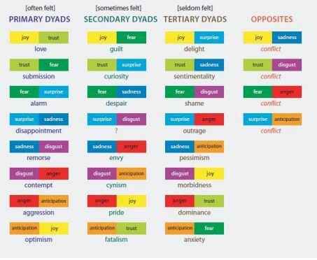

**Figure 4.8 Dyadic implications (Drews, 2007)**